EXPERIMENT 1A
EXPERIMENT 1A:
#include <stdio.h>
#include <time.h>

int main () {
int arr[100], i, n, c, found = 0;
clock_t start, end;
double cpu_time_used;

printf("Enter N: ");
scanf("%d", &n);

printf("Enter Array of %d elements:\n", n);
for (i = 0; i < n; i++) {
scanf("%d", &arr[i]);
}

printf("Enter Search element c:");
scanf("%d", &c);

start = clock();

for (i = 0; i < n; i++) {
if (arr[i] == c) {
printf("Element %d found in position %d\n", c, i + 1);
found = 1;
break;
}
}

end = clock();

if (!found) {
printf("Element %d not found\n", c);
}

cpu_time_used = ((double)(end - start)) / CLOCKS_PER_SEC;
printf("Execution time: %.6f Seconds\n", cpu_time_used);

return 0; // Note: This function is non-standard (usually conio.h)
}
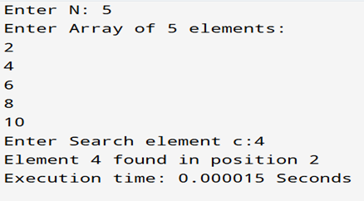

EXPERIMENT 1B
EXPERIMENT 1B:
#include <stdio.h>
#include <time.h>

int binarySearch(int arr[], int n, int key) {
int low = 0;
int high = n - 1;

while (low <= high) {
int mid = (high + low) / 2;

if (arr[mid] == key) {
return mid;
} else if (arr[mid] < key) {
low = mid + 1;
} else {
high = mid - 1;
}
}

return -1;
}

int main() {
int n = 100000;
int arr[n];

for (int i = 0; i < n; i++) {
arr[i] = i;
}

int key = 99999;

clock_t start, end;
double cpu_time_used;

start = clock();

int result = binarySearch(arr, n, key);

end = clock();

cpu_time_used = ((double)(end - start)) / CLOCKS_PER_SEC;

if (result != -1) {
printf("Element found at index %d\n", result);
} else {
printf("Element not found\n");
}
printf("Execution time: %.6f seconds\n", cpu_time_used);
return 0; }
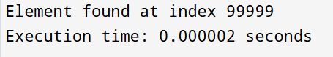

EXPERIMENT 1C
EXPERIMENT 1C:
#include <stdio.h>
#include <time.h>

int recursiveLinearSearch(int arr[], int size, int key, int index) {
if (index == size) {
return -1;
}

if (arr[index] == key) {
return index;
}

return recursiveLinearSearch(arr, size, key, index + 1);
}

int main() {
int n = 100000;
int arr[n];

for (int i = 0; i < n; i++) {
arr[i] = i;
}

int key = 99999;

clock_t start, end;
double cpu_time_used;

start = clock();

// Start search from index 0
int result = recursiveLinearSearch(arr, n, key, 0);

end = clock();

cpu_time_used = ((double)(end - start)) / CLOCKS_PER_SEC;

if (result != -1) {
printf("Element found at index %d\n", result);
} else {
printf("Element not found\n");
}

printf("Execution time: %.6f seconds\n", cpu_time_used);

return 0;
}

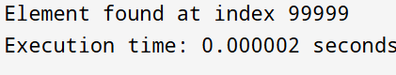

EXPERIMENT 1D
EXPERIMENT 1D:
#include <stdio.h>
#include <time.h>

int recursiveBinarySearch(int arr[], int low, int high, int key) {
if (low > high) {
return -1; // Element not found
}

int mid = low + (high - low) / 2; // Safer mid calculation

if (arr[mid] == key) {
return mid;
}
else if (arr[mid] > key) {
// Search the left half
return recursiveBinarySearch(arr, low, mid - 1, key);
}
else {
// Search the right half
return recursiveBinarySearch(arr, mid + 1, high, key);
}
}

int main() {
int n = 100000;
int arr[n];

for (int i = 0; i < n; i++) {
arr[i] = i;
}

int key = 99999;

clock_t start, end;
double cpu_time_used;

start = clock();

// Initial call: low=0, high=n-1
int result = recursiveBinarySearch(arr, 0, n - 1, key);

end = clock();
cpu_time_used = ((double)(end - start)) / CLOCKS_PER_SEC;
if (result != -1) {
printf("Element found at index %d\n", result);
} else {
printf("Element not found\n");
} return 0; }

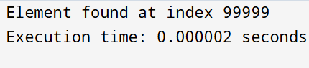

EXPERIMENT 2A
EXPERIMENT 2A:
#include <stdio.h>
#include <time.h>

void insertionSort(int array[], int n) {
int i, element, j;

for (i = 1; i < n; i++) {
element = array[i];
j = i - 1;

// Move elements of array[0..i-1], that are greater than element,
// to one position ahead of their current position
while (j >= 0 && array[j] > element) {
array[j + 1] = array[j];
j = j - 1;
}
array[j + 1] = element;
}
}

void printArray(int array[], int n) {
int i;
for (i = 0; i < n; i++) {
printf("%d ", array[i]);
}
printf("\n");
}

int main() {
int arr[] = {50, 23, 9, 18, 61, 32};

clock_t start, end;
double cpu_time_used;

// Calculate the number of elements in the array
int n = sizeof(arr) / sizeof(arr[0]);

printf("\nBefore sorting: ");
printArray(arr, n);

start = clock();

insertionSort(arr, n);
end = clock();
printf("\nAfter sorting: ");
printArray(arr, n);
cpu_time_used = ((double)(end - start)) / CLOCKS_PER_SEC;
printf("Execution time: %.6f seconds\n", cpu_time_used);
return 0;
}
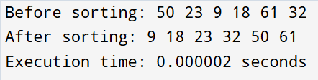

EXPERIMENT 2B
EXPERIMENT 2B:
#include <stdio.h>
#include <time.h>

// Define a structure to hold both maximum and minimum elements
struct pair {
int max;
int min;
};
struct pair maxMinDivideConquer(int arr[], int low, int high) {
struct pair result, left, right;
int mid;

// Case 1: Small problem size (only 1 element)
if (low == high) {
result.max = arr[low];
result.min = arr[low];
return result;
}

// Case 2: Small problem size (only 2 elements)
if (high == low + 1) {
if (arr[low] < arr[high]) {
result.min = arr[low];
result.max = arr[high];
} else {
result.min = arr[high];
result.max = arr[low];
}
return result;
}

// Case 3: Problem size > 2 (Divide and Conquer)
mid = low + (high - low) / 2; // Calculate middle index

// Divide: Recursively find max and min in the two halves
left = maxMinDivideConquer(arr, low, mid);
right = maxMinDivideConquer(arr, mid + 1, high);

// Conquer: Combine the results

// Find the overall maximum
if (left.max > right.max) {
result.max = left.max;
} else {
result.max = right.max;
}

// Find the overall minimum
if (left.min < right.min) {
result.min = left.min;
} else {
result.min = right.min;
}

return result;
}

int main() {
// Array definition and size calculation
int arr[] = {6, 4, 26, 14, 33, 64, 46};
int n = sizeof(arr) / sizeof(arr[0]);

// Timing variables
clock_t start, end;
double cpu_time_used;

// Start timing
start = clock();

// Call the function
// Pass the full array range: 0 to n-1
struct pair result = maxMinDivideConquer(arr, 0, n - 1);

// Stop timing
end = clock();

// Print results
printf("Maximum element: %d\n", result.max);

printf("Minimum element: %d\n", result.min);

// Calculate time
cpu_time_used = ((double)(end - start)) / CLOCKS_PER_SEC;

// Print execution time
printf("Execution time: %.6f seconds\n", cpu_time_used);

return 0;
}

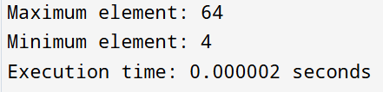

EXPERIMENT 3A
EXPERIMENT 3A:
#include <stdio.h>
#include <stdlib.h> // Required for malloc and free
#include <time.h>
void merge(int arr[], int left, int mid, int right) {
int i, j, k;

// Calculate the size of the two subarrays
int n1 = mid - left + 1;
int n2 = right - mid; // The number of elements in the right subarray

// Create temporary arrays L and R
// Using malloc to dynamically allocate memory
int *L = (int *)malloc(n1 * sizeof(int));
int *R = (int *)malloc(n2 * sizeof(int));

// Copy data to temp arrays L[] and R[]
for (i = 0; i < n1; i++) {
L[i] = arr[left + i];
}
for (j = 0; j < n2; j++) {
R[j] = arr[mid + 1 + j];
}

// Merge the temp arrays back into arr[left..right]
i = 0; // Initial index of first subarray
j = 0; // Initial index of second subarray
k = left; // Initial index of merged subarray

while (i < n1 && j < n2) {
if (L[i] <= R[j]) {
arr[k] = L[i];
i++;
} else {
arr[k] = R[j];
j++;
}
k++;
}

// Copy the remaining elements of L[], if any
while (i < n1) {
arr[k] = L[i];
i++;
k++;
}

// Copy the remaining elements of R[], if any
while (j < n2) {
arr[k] = R[j];
j++;
k++;
}

// Free the dynamically allocated memory
free(L);
free(R);
}
void mergeSort(int arr[], int left, int right) {
if (left < right) {
// Find the middle point
int mid = left + (right - left) / 2;

// Recursively sort the first and second halves
mergeSort(arr, left, mid);
mergeSort(arr, mid + 1, right);

// Merge the sorted halves
merge(arr, left, mid, right);
}
}
void printArray(int arr[], int size) {
int i;
for (i = 0; i < size; i++) {
printf("%d ", arr[i]);
}
printf("\n");
}

int main() {
int arr[] = {12, 11, 13, 5, 6, 7};

clock_t start, end;
double cpu_time_used;

// Calculate the number of elements in the array
int n = sizeof(arr) / sizeof(arr[0]);

printf("Array is:\n");
printArray(arr, n);

start = clock();

// Call mergeSort with the initial range (0 to n-1)
mergeSort(arr, 0, n - 1);

end = clock();

printf("\nSorted:\n");
printArray(arr, n);

// Calculate time
cpu_time_used = ((double)(end - start)) / CLOCKS_PER_SEC;

// Print execution time
printf("\nExecution time: %.6f seconds\n", cpu_time_used);

return 0;
}

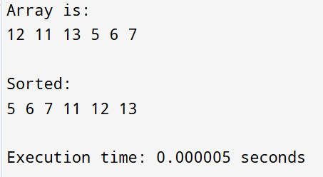

EXPERIMENT 3B
EXPERIMENT 3B:
#include <stdio.h>
#include <time.h>
void swap(int* a, int* b) {
int temp = *a;
*a = *b;
*b = temp;
}

int partition(int arr[], int low, int high) {
int pivot = arr[high]; // Pivot is the last element
int i = (low - 1); // Index of smaller element

for (int j = low; j <= high - 1; j++) {
// If current element is smaller than or equal to pivot
if (arr[j] <= pivot) {
i++; // Increment index of smaller element
swap(&arr[i], &arr[j]);
}
}
// Swap the pivot element with the element at the index i+1
swap(&arr[i + 1], &arr[high]);
return (i + 1);
}
void quickSort(int arr[], int low, int high) {
if (low < high) {
// pIndex is partitioning index, arr[pIndex] is now at correct place
int pIndex = partition(arr, low, high);

// Separately sort elements before and after partition
quickSort(arr, low, pIndex - 1);
quickSort(arr, pIndex + 1, high);
}
}
void printArray(int arr[], int size) {
int i;
for (i = 0; i < size; i++) {
printf("%d ", arr[i]);
}
printf("\n");
}

int main() {
int arr[] = {10, 7, 8, 9, 1, 5};

clock_t start, end;
double cpu_time_used;

// Calculate the number of elements in the array
int n = sizeof(arr) / sizeof(arr[0]);

printf("Array:\n");
printArray(arr, n);

start = clock();

// Call quickSort with the initial range (0 to n-1)
quickSort(arr, 0, n - 1);

end = clock();

printf("\nSorted:\n");
printArray(arr, n);

// Calculate time
cpu_time_used = ((double)(end - start)) / CLOCKS_PER_SEC;

// Print execution time
printf("Execution time: %.6f seconds\n", cpu_time_used);

return 0;
}

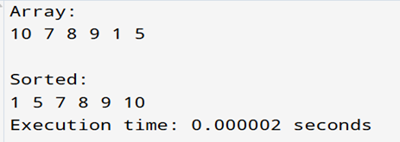

EXPERIMENT 4A
EXPERIMENT 4A:
#include <stdio.h>
#include <stdbool.h>
#include <time.h>

#define N 8 // Change this for different board sizes

static void printSolution(int board[N][N])
{
for (int i = 0; i < N; ++i)
{
for (int j = 0; j < N; ++j)
printf("%c ", board[i][j] ? 'Q' : '.');
printf("\n");
}
printf("\n");
}

static bool isSafe(int board[N][N], int row, int col)
{
// Check current row on the left side
for (int i = 0; i < col; ++i)
if (board[row][i])
return false;

// Check upper-left diagonal
for (int i = row, j = col; i >= 0 && j >= 0; --i, --j)
if (board[i][j])
return false;

// Check lower-left diagonal
for (int i = row, j = col; i < N && j >= 0; ++i, --j)
if (board[i][j])
return false;

return true;
}

static bool solveNQUtil(int board[N][N], int col)
{
if (col >= N)
return true; // All queens placed

for (int i = 0; i < N; ++i)
{
if (isSafe(board, i, col))
{
board[i][col] = 1;
if (solveNQUtil(board, col + 1))
return true;
board[i][col] = 0; // Backtrack
}
}
return false;
}

static void solveNQ(void)
{
int board[N][N];
// Initialize to 0
for (int i = 0; i < N; ++i)
for (int j = 0; j < N; ++j)
board[i][j] = 0;

if (!solveNQUtil(board, 0))
{
printf("Solution does not exist.\n");
return;
}

printSolution(board);
}

int main(void)
{
clock_t start,end;
double cpu_time_used;
start=clock();
solveNQ();
end=clock();
cpu_time_used = ((double)(end-start)) / CLOCKS_PER_SEC;
printf("Execution time: %.6f seconds\n", cpu_time_used);

return 0;
}

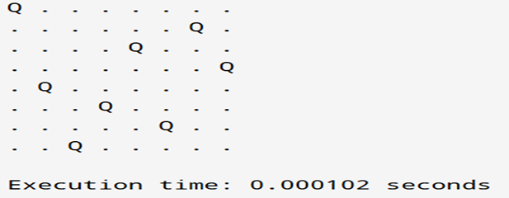

EXPERIMENT 4B
EXPERIMENT 4B:
#include <stdio.h>
#include<time.h>
void findSubset(int set[], int subset[], int n, int index, int target, int currentSum) { if (currentSum == target) {
printf("Subset found: ");
for (int i = 0; i < index; i++) {
printf("%d ", subset[i]);
}
printf("\n");
return;
}
if (currentSum > target || n == 0) {
return;
}
// Include the current element
subset[index] = set[0];
findSubset(set + 1, subset, n - 1, index + 1, target, currentSum + set[0]);
// Exclude the current element
findSubset(set + 1, subset, n - 1, index, target, currentSum); }
int main() {
int n, target;
clock_t start,end;
double cpu_time_used;
printf("Enter the number of elements in the set: "); scanf("%d", &n);
int set[n], subset[n];
printf("Enter the elements of the set: "); for (int i = 0; i < n; i++) {
scanf("%d", &set[i]);
}
printf("Enter the target sum: ");
scanf("%d", &target);
printf("Subsets with sum %d:\n", target);
start=clock();
findSubset(set, subset, n, 0, target, 0);
end=clock();
cpu_time_used=((double)(end-start))/CLOCKS_PER_SEC;
printf("Execution time:%f second",cpu_time_used);
return 0;
}

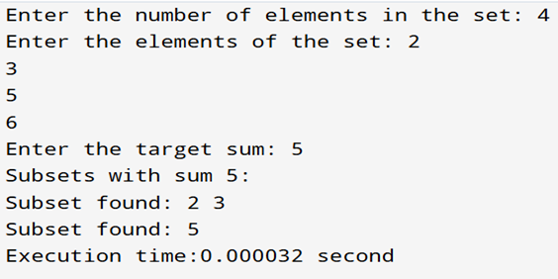

EXPERIMENT 5A
EXPERIMENT 5A:

#include <stdio.h>
#include <time.h>

// Function to find the maximum of two integers
int max(int a, int b) {
return (a > b) ? a : b;
}

// Function to solve the 0/1 Knapsack problem
int knapsack(int W, int wt[], int val[], int n) {
int i, w;
// Create a 2D array to store results of subproblems
// knap[i][w] will store the maximum value for 'i' items and capacity 'w'
int knap[n + 1][W + 1];

// Build the knap table in a bottom-up manner
for (i = 0; i <= n; i++) {
for (w = 0; w <= W; w++) {
// Base case: If no items or no capacity, value is 0
if (i == 0 || w == 0) {
knap[i][w] = 0;
} else if (wt[i - 1] <= w) {
// Take the maximum of two cases:
// 1. Include the current item: val[i-1] + knap[i-1][w - wt[i-1]]
// 2. Exclude the current item: knap[i-1][w]
knap[i][w] = max(val[i - 1] + knap[i - 1][w - wt[i - 1]], knap[i - 1][w]);
} else {
// If current item's weight is more than current capacity, exclude it
knap[i][w] = knap[i - 1][w];
}
}
}
// The maximum value will be in knap[n][W]
return knap[n][W];
}

// Driver code to test the knapsack function
int main() {
clock_t start, end;
double cpu_time_used;
int val[] = {60, 100, 120}; // Values of items
int wt[] = {10, 20, 30}; // Weights of items
int W = 50; // Maximum capacity of the knapsack
int n = sizeof(val) / sizeof(val[0]); // Number of items

start = clock();
printf("The maximum value that can be put in the knapsack is: %d\n", knapsack(W, wt, val, n));
end = clock();

cpu_time_used = ((double)(end - start) / CLOCKS_PER_SEC);
printf("Execution time: %f seconds\n", cpu_time_used);

return 0;
}

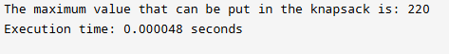

EXPERIMENT 5B
EXPERIMENT 5B:

#include <stdio.h>
#include <stdlib.h>
#include<time.h>
// Structure to represent an item
typedef struct {
int itemId;
int weight;
int profit;
float pByw; // Profit-to-weight ratio
} Item;
// Comparison function for sorting items by profit-to-weight ratio in descending order
int compareItems(const void *a, const void *b) {
Item *itemA = (Item *)a;
Item *itemB = (Item *)b;
if (itemA->pByw < itemB->pByw) return 1;
if (itemA->pByw > itemB->pByw) return -1;
return 0;
}
// Function to solve the Fractional Knapsack problem
float fractionalKnapsack(Item *items, int n, int capacity) {
// Sort items based on profit-to-weight ratio in descending order
qsort(items, n, sizeof(Item), compareItems);
float totalProfit = 0.0;
int currentWeight = 0;
for (int i = 0; i < n; i++) {
// If the current item can be taken completely
if (currentWeight + items[i].weight <= capacity) {
currentWeight += items[i].weight;
totalProfit += items[i].profit;
printf("Added item %d (Weight: %d, Profit: %d) completely. Current weight: %d, Total profit: %.2f\n",
items[i].itemId, items[i].weight, items[i].profit, currentWeight, totalProfit); } else {
// Take a fraction of the current item
float remainingCapacity = capacity - currentWeight;
float fraction = remainingCapacity / items[i].weight;
totalProfit += fraction * items[i].profit;
currentWeight += remainingCapacity; // Knapsack is now full
printf("Added %.2f%% of item %d (Weight: %d, Profit: %d). Current weight: %d, Total profit: %.2f\n",
fraction * 100, items[i].itemId, items[i].weight, items[i].profit, currentWeight, totalProfit);
break; // Knapsack is full, no more items can be added
}
}
return totalProfit;
}
int main() {
clock_t start, end;
double cpu_time_used;

int n, knapsackCapacity;
printf("Enter the number of items: ");
scanf("%d", &n);
Item *items = (Item *)malloc(sizeof(Item) * n);
if (items == NULL) {
printf("Memory allocation failed.\n");
return 1;
}
printf("Enter itemId, weight, and profit for each item:\n"); for (int i = 0; i < n; i++) {
printf("Item %d: ", i + 1);
scanf("%d %d %d", &items[i].itemId, &items[i].weight, &items[i].profit); items[i].pByw = (float)items[i].profit / items[i].weight; }
printf("Enter the knapsack capacity: ");
scanf("%d", &knapsackCapacity);
start=clock();
float maxProfit = fractionalKnapsack(items, n, knapsackCapacity); printf("\nMaximum profit for the given capacity: %.2f\n", maxProfit);
free(items);
end = clock();

cpu_time_used = ((double)(end - start) / CLOCKS_PER_SEC);
printf("Execution time: %f seconds\n", cpu_time_used);

return 0; }

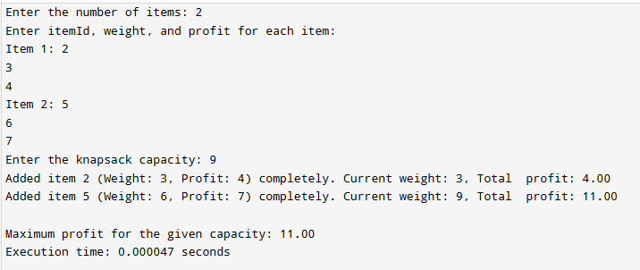

EXPERIMENT 6A
EXPERIMENT 6A

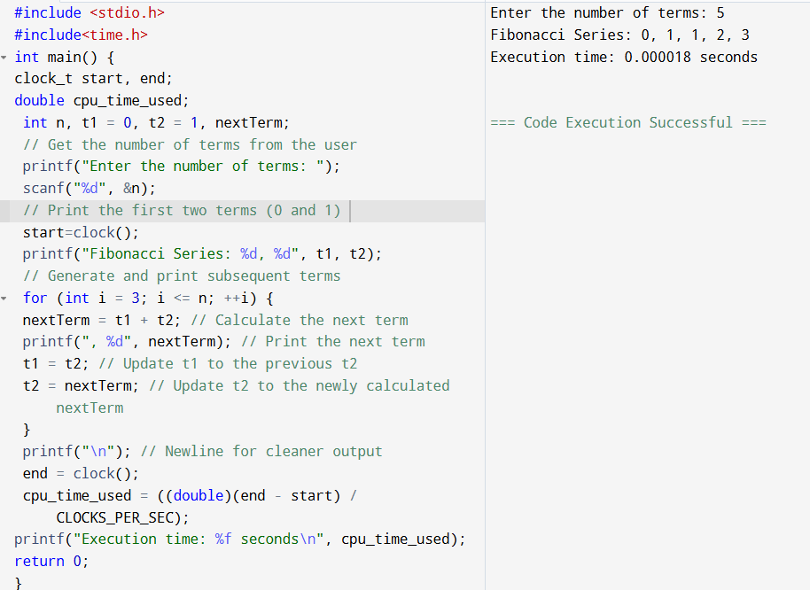

EXPERIMENT 6B
EXPERIMENT 6B

#include <stdio.h>
#include <string.h>
#include<time.h>
// Function to find the maximum of two integers
int max(int a, int b) {
return (a > b) ? a : b;
}
// Function to find the Longest Common Subsequence (LCS)
int lcs(char *X, char *Y, int m, int n) {
int L[m + 1][n + 1]; // DP table to store lengths of LCS
// Fill the L table in bottom-up manner
for (int i = 0; i <= m; i++) {
for (int j = 0; j <= n; j++) {
if (i == 0 || j == 0) {
L[i][j] = 0; // Base case: if either string is empty, LCS is 0
} else if (X[i - 1] == Y[j - 1]) {
L[i][j] = L[i - 1][j - 1] + 1; // Characters match, add 1 to diagonal
} else {
L[i][j] = max(L[i - 1][j], L[i][j - 1]); // Characters don't match, take max of above or left
}
}
}
// L[m][n] contains the length of LCS. Now, reconstruct the LCS string.
int index = L[m][n];
char lcs_str[index + 1];
lcs_str[index] = '\0'; // Null-terminate the string
int i = m, j = n;
while (i > 0 && j > 0) {
if (X[i - 1] == Y[j - 1]) {
lcs_str[index - 1] = X[i - 1]; // Character is part of LCS
i--;
j--;
index--;
} else if (L[i - 1][j] > L[i][j - 1]) {
i--; // Move up
} else {
j--; // Move left
}
}
printf("Longest Common Subsequence: %s\n", lcs_str);
return L[m][n]; // Return the length of LCS
}
int main() {
clock_t start, end;
double cpu_time_used;
char X[] = "AGGTAB";
char Y[] = "GXTXAYB";
int m = strlen(X);
int n = strlen(Y);
start=clock();
printf("Length of LCS is %d\n", lcs(X, Y, m, n));
end = clock();
cpu_time_used = ((double)(end - start) / CLOCKS_PER_SEC);
printf("Execution time: %f seconds\n", cpu_time_used);
return 0;
}

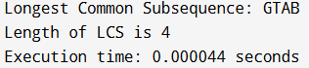

EXPERIMENT 7A
EXPERIMENT 7A:

#include <stdio.h>
#include <stdlib.h>
#include <time.h> // Include for time measurement

// Global variables
int i, j, k, a, b, u, v, n, ne = 1;
int min, mincost = 0;
int cost[9][9];
int parent[9] = {0}; // Initialized to zero

// Function declarations
int find(int);
int uni(int, int);

// Find the root of the set containing element i
int find(int i)
{
while (parent[i])
i = parent[i];
return i;
}

// Union the sets containing elements i and j. Returns 1 if a union occurs, 0 otherwise.
int uni(int i, int j)
{
if (i != j)
{
parent[j] = i;
return 1;
}
return 0;
}

int main(void) // Standard C main function
{
printf("Kruskal's algorithm in C\n");
printf("========================\n");

printf("Enter the no. of vertices (max 8):\n");
if (scanf("%d", &n) != 1 || n < 1 || n >= 9) return 1;

printf("\nEnter the cost adjacency matrix (0 for no edge):\n");
for (i = 1; i <= n; i++)
{
for (j = 1; j <= n; j++)
{
if (scanf("%d", &cost[i][j]) != 1) return 1;
// Use 999 for no edge
if (cost[i][j] == 0)
cost[i][j] = 999;
}
}

// START TIMING
clock_t start = clock();

printf("The edges of Minimum Cost Spanning Tree are\n");

// Kruskal's main loop: continues until n-1 edges are added
while (ne < n)
{
// Step 1: Find the minimum cost edge (a, b)
for (i = 1, min = 999; i <= n; i++)
{
for (j = 1; j <= n; j++)
{
if (cost[i][j] < min)
{
min = cost[i][j];
a = u = i;
b = v = j;
}
}
}

// Step 2: Check for cycle using DSU operations
u = find(u);
v = find(v);

if (uni(u, v)) // If union is successful (no cycle)
{
printf("%d edge (%d,%d) = %d\n", ne++, a, b, min);
mincost += min;
}

// Step 3: Mark the edge as processed
cost[a][b] = cost[b][a] = 999; // Use 999 to mark as processed
}

// STOP TIMING
clock_t end = clock();
double cpu_time_used = ((double) (end - start)) / CLOCKS_PER_SEC;

printf("\nMinimum cost = %d\n", mincost);
printf("Execution time: %.6f seconds\n", cpu_time_used);

return 0;
}

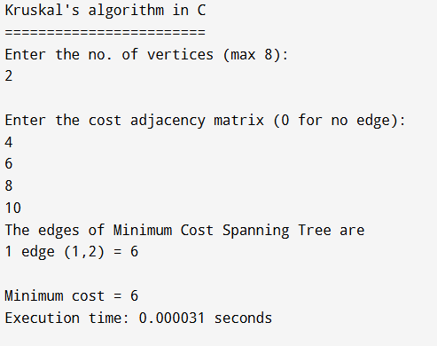

EXPERIMENT 7B
EXPERIMENT 7B:

#include <stdio.h>
#include <stdlib.h>
#include <time.h> // Include for time measurement

#define INFINITY 9999
#define MAX 10

void dijkstra(int G[MAX][MAX], int n, int startnode);

int main(void)
{
int G[MAX][MAX], i, j, n, u;

printf("Enter no. of vertices (max %d): ", MAX);
if (scanf("%d", &n) != 1 || n <= 0 || n > MAX)
{
fprintf(stderr, "Invalid number of vertices.\n");
return 1;
}

printf("\nEnter the adjacency matrix (0 for no edge or self-loop):\n");
for (i = 0; i < n; i++)
{
for (j = 0; j < n; j++)
{
if (scanf("%d", &G[i][j]) != 1)
{
fprintf(stderr, "Input error.\n");
return 1;
}
}
}

printf("\nEnter the starting node (0 to %d): ", n - 1);
if (scanf("%d", &u) != 1 || u < 0 || u >= n)
{
fprintf(stderr, "Invalid starting node.\n");
return 1;
}

dijkstra(G, n, u);

return 0;
}

void dijkstra(int G[MAX][MAX], int n, int startnode)
{
// Arrays for algorithm state
int cost[MAX][MAX], distance[MAX], pred[MAX];
int visited[MAX], count, mindistance, nextnode, i, j;

// START TIMING
clock_t start_time = clock();

// Create the cost matrix: replace 0 (no edge) with INFINITY
for(i = 0; i < n; i++)
{
for(j = 0; j < n; j++)
{
if(G[i][j] == 0)
cost[i][j] = INFINITY;
else
cost[i][j] = G[i][j];
}
}

// Initialize pred[], distance[] and visited[]
for(i = 0; i < n; i++)
{
// Initial distance from startnode to i is the direct edge cost
distance[i] = cost[startnode][i];
pred[i] = startnode;
visited[i] = 0;
}

distance[startnode] = 0;
visited[startnode] = 1;
count = 1;

// The loop runs n-1 times to find shortest paths to n-1 nodes
while(count < n) // Corrected termination condition: needs to process n nodes (count < n)
{
mindistance = INFINITY;

// Step 1: Find the next unvisited node with the minimum distance
for(i = 0; i < n; i++)
{
if(distance[i] < mindistance && !visited[i])
{
mindistance = distance[i];
nextnode = i;
}
}

// Check if all remaining nodes are unreachable (distance remains INFINITY)
if (mindistance == INFINITY)
break;

// Step 2: Mark the found node as visited
visited[nextnode] = 1;

// Step 3: Update distances to its neighbors through the nextnode
for(i = 0; i < n; i++)
{
if(!visited[i])
{
if(mindistance + cost[nextnode][i] < distance[i])
{
distance[i] = mindistance + cost[nextnode][i];
pred[i] = nextnode;
}
}
}
count++;
}

// STOP TIMING
clock_t end_time = clock();
double cpu_time_used = ((double) (end_time - start_time)) / CLOCKS_PER_SEC;

// Print the path and distance of each node
printf("\nShortest paths from node %d:\n", startnode);
for(i = 0; i < n; i++)
{
if(i != startnode)
{
printf("\nDistance to node %d = %d", i, distance[i]);
printf("\nPath: %d", i);

// Print path by backtracking using the predecessor array
j = i;
if (distance[i] != INFINITY)
{
do
{
j = pred[j];
printf(" <- %d", j);
} while(j != startnode);
}
}
}

printf("\n\nExecution time: %.6f seconds\n", cpu_time_used);
}

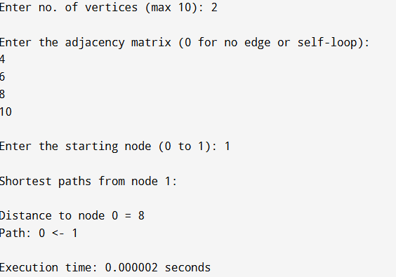

EXPERIMENT 8
EXPERIMENT 8:

#include <stdio.h>
#include <stdlib.h>
#include <time.h> // For clock() and CLOCKS_PER_SEC

// Structure to represent a point
typedef struct
{
int first;
int second;
} Pair;

// Global variable to store the center of the polygon
Pair mid;

// Function to determine the quadrant of a point relative to 'mid'
int quad(Pair p)
{
// The point p here represents the difference (p - mid)
if (p.first >= 0 && p.second >= 0)
return 1;
if (p.first <= 0 && p.second >= 0)
return 2;
if (p.first <= 0 && p.second <= 0)
return 3;
return 4; // p.first >= 0 && p.second <= 0
}

// Function to check the orientation of three points (cross-product sign)
// Returns: 1 (CCW), 0 (Collinear), -1 (CW)
int orientation(Pair a, Pair b, Pair c)
{
long long res = (long long)(b.second - a.second) * (c.first - b.first) - (long long)(c.second - b.second) * (b.first - a.first);
if (res == 0)
return 0;
if (res > 0)
return 1; // Counter-Clockwise (Left Turn)
return -1; // Clockwise (Right Turn)
}

// Compare function for sorting by Polar Angle around 'mid'
int compare(const void *p1, const void *q1)
{
Pair *p = (Pair *)p1;
Pair *q = (Pair *)q1;
Pair p_diff = {p->first - mid.first, p->second - mid.second};
Pair q_diff = {q->first - mid.first, q->second - mid.second};

int one = quad(p_diff);
int two = quad(q_diff);

// Sort by quadrant first
if (one != two)
return (one < two) ? -1 : 1;

// Within the same quadrant, use cross product to determine angle
// Cross product: (p - mid) x (q - mid)
// Positive result means p is CCW from q (smaller angle), so p comes first (-1)
long long cross_product = (long long)p_diff.second * q_diff.first - (long long)q_diff.second * p_diff.first;

if (cross_product == 0) return 0; // Collinear

return (cross_product > 0) ? -1 : 1; // CCW (-1) or CW (1)
}

// Compare function for initial sorting by X-coordinate (and Y as tie-breaker)
int compare_x(const void *p1, const void *q1)
{
Pair *p = (Pair *)p1;
Pair *q = (Pair *)q1;

if (p->first != q->first)
return p->first - q->first;
return p->second - q->second;
}

// Function to merge two convex hulls
Pair *merger(Pair *a, int n1, Pair *b, int n2, int *ret_size) {
// ... (merger function body is unchanged) ...
// Find rightmost point on A (ia) and leftmost point on B (ib)
int ia = 0, ib = 0;
for (int i = 1; i < n1; i++)
if (a[i].first > a[ia].first)
ia = i;
for (int i = 1; i < n2; i++)
if (b[i].first < b[ib].first)
ib = i;

// Find Upper Tangent
int inda = ia, indb = ib;
int done = 0;
while (!done)
{
done = 1;
// Move inda CCW on A until b[indb] -> a[inda] -> a[next] is CW or Collinear (>= 0)
while (orientation(b[indb], a[inda], a[(inda + 1) % n1]) >= 0)
inda = (inda + 1) % n1;

// Move indb CW on B until a[inda] -> b[indb] -> b[prev] is CW or Collinear (<= 0)
while (orientation(a[inda], b[indb], b[(n2 + indb - 1) % n2]) <= 0)
{
indb = (n2 + indb - 1) % n2;
done = 0;
}
}
int uppera = inda, upperb = indb;

// Find Lower Tangent
inda = ia;
indb = ib;
done = 0;
while (!done)
{
done = 1;
// Move indb CCW on B until a[inda] -> b[indb] -> b[next] is CW or Collinear (>= 0)
while (orientation(a[inda], b[indb], b[(indb + 1) % n2]) >= 0)
indb = (indb + 1) % n2;

// Move inda CW on A until b[indb] -> a[inda] -> a[prev] is CW or Collinear (<= 0)
while (orientation(b[indb], a[inda], a[(n1 + inda - 1) % n1]) <= 0)
{
inda = (n1 + inda - 1) % n1;
done = 0;
}
}
int lowera = inda, lowerb = indb;

// Construct the merged hull
Pair *ret = (Pair *)malloc((n1 + n2) * sizeof(Pair));
int k = 0;

// Trace from uppera to lowera on A
int ind = uppera;
ret[k++] = a[uppera];
while (ind != lowera)
{
ind = (ind + 1) % n1;
ret[k++] = a[ind];
}

// Trace from lowerb to upperb on B
ind = lowerb;
ret[k++] = b[lowerb];
while (ind != upperb)
{
ind = (ind + 1) % n2;
ret[k++] = b[ind];
}

*ret_size = k;

// Free the memory of the sub-hulls
free(a);
free(b);

// Reallocate to the correct size
Pair *final_ret = (Pair *)realloc(ret, k * sizeof(Pair));
// Check for realloc failure (though unlikely here)
if (final_ret == NULL) {
// Handle error if realloc fails
*ret_size = 0;
return NULL;
}
return final_ret;
}

// Brute force algorithm to find the convex hull for a small set of points
Pair *bruteHull(Pair *a, int n, int *ret_size)
{
// ... (bruteHull function body is unchanged, but corrected for dynamic allocation) ...
// Note: The logic for calculating mid (centroid) in this function is unusual (multiplying coordinates by k before division)
// but retained to match the original intent. The main logic for edge checking is standard O(N^3) or O(N^2).

Pair *temp_hull = (Pair *)malloc(n * sizeof(Pair));
int k = 0;

// Brute force: Check every segment
for (int i = 0; i < n; i++)
{
for (int j = i + 1; j < n; j++)
{
// Line equation: a1*x + b1*y + c1 = 0
long long x1 = a[i].first, x2 = a[j].first;
long long y1 = a[i].second, y2 = a[j].second;
long long a1 = y1 - y2;
long long b1 = x2 - x1;
long long c1 = x1 * y2 - y1 * x2;

int pos = 0, neg = 0;
// Check which side of the line all other points lie
for (int m = 0; m < n; m++)
{
long long val = a1 * a[m].first + b1 * a[m].second + c1;
if (val <= 0)
neg++;
if (val >= 0)
pos++;
}

// If all points are on one side (pos == n OR neg == n), the segment is a hull edge
if (pos == n || neg == n)
{
int already_added;

// Add point i if not already in the hull
already_added = 0;
for (int l = 0; l < k; l++)
{
if (temp_hull[l].first == a[i].first && temp_hull[l].second == a[i].second)
already_added = 1;
}
if (!already_added)
temp_hull[k++] = a[i];

// Add point j if not already in the hull
already_added = 0;
for (int l = 0; l < k; l++)
{
if (temp_hull[l].first == a[j].first && temp_hull[l].second == a[j].second)
already_added = 1;
}
if (!already_added)
temp_hull[k++] = a[j];
}
}
}

*ret_size = k;

// Prepare for polar angle sort (calculate centroid 'mid')
Pair *ret = (Pair *)realloc(temp_hull, k * sizeof(Pair)); // Final hull array
if (ret == NULL && k > 0) return NULL; // Handle realloc failure
if (k == 0) { *ret_size = 0; return NULL; } // Handle empty hull

mid.first = 0;
mid.second = 0;
for (int i = 0; i < k; i++)
{
mid.first += ret[i].first;
mid.second += ret[i].second;
// The following lines in the original code are unnecessary and potentially problematic:
// ret[i].first *= k;
// ret[i].second *= k;
}

// Sort the hull points by polar angle around the centroid
qsort(ret, k, sizeof(Pair), compare);

// The following loop from the original code is unnecessary after removing the 'multiply by k' lines
/*
for (int i = 0; i < k; i++)
{
ret[i].first /= k;
ret[i].second /= k;
}
*/

return ret;
}

// Function to divide the set of points and recursively find the convex hull
Pair *divide(Pair *a, int n, int *ret_size)
{
// The input array 'a' is a segment of the original points,
// it must be copied for the recursive calls to manage memory correctly.

// Copy the current segment of points for the left half
Pair *left_copy = (Pair *)malloc((n / 2) * sizeof(Pair));
for(int i = 0; i < n / 2; i++) {
left_copy[i] = a[i];
}

// Copy the current segment of points for the right half
Pair *right_copy = (Pair *)malloc((n - n / 2) * sizeof(Pair));
for(int i = 0; i < n - n / 2; i++) {
right_copy[i] = a[n / 2 + i];
}

if (n <= 5)
{
// For the base case, use the original segment's address and size,
// as bruteHull handles its own memory allocation/reallocation.
Pair *hull = bruteHull(a, n, ret_size);
free(left_copy); // Free the copies that won't be used
free(right_copy);
return hull;
}

int mid_idx = n / 2;
Pair *left_hull;
Pair *right_hull;
int left_size, right_size;

// Recursively find hulls of the copied segments
left_hull = divide(left_copy, mid_idx, &left_size);
right_hull = divide(right_copy, n - mid_idx, &right_size);

// Free the copies after they have been used to generate the sub-hulls
free(left_copy);
free(right_copy);

// Merge the two hulls (merger frees the sub-hulls)
return merger(left_hull, left_size, right_hull, right_size, ret_size);
}

// Driver code
int main()
{
Pair a[] = {{0, 0}, {1, -4}, {-1, -5}, {-5, -3}, {-3, -1},
{-1, -3}, {-2, -2}, {-1, -1}, {-2, -1}, {-1, 1}};
int n = sizeof(a) / sizeof(a[0]);

clock_t start, end;
double cpu_time_used;

// 1. Initial Sort: The 'divide' step requires points to be sorted by X-coordinate
qsort(a, n, sizeof(Pair), compare_x);

// 2. Start Timing
start = clock();

// 3. Find the Convex Hull
int ret_size;

// Create a copy of 'a' since 'divide' and 'merger' will manage/free memory
Pair *a_copy = (Pair *)malloc(n * sizeof(Pair));
for(int i = 0; i < n; i++) a_copy[i] = a[i];

Pair *ans = divide(a_copy, n, &ret_size);

// 4. End Timing
end = clock();

// 5. Output Result and Time
printf("Convex hull vertices:\n");
if (ans != NULL) {
for (int i = 0; i < ret_size; i++)
{
printf("(%d, %d)\n", ans[i].first, ans[i].second);
}
free(ans);
} else {
printf("Could not compute convex hull.\n");
}

free(a_copy); // Free the copy

cpu_time_used = ((double)(end - start)) / CLOCKS_PER_SEC;
printf("\nExecution time: %f seconds\n", cpu_time_used);

return 0;
}

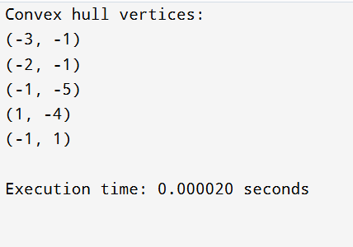

EXPERIMENT 9
EXPERIMENT 9:

#include <stdio.h>
#include <stdlib.h>
#include<time.h>
// Function to perform modular exponentiation
long long power_mod(long long base, long long exp, long long mod) { long long result = 1;
base = base % mod;
while (exp > 0) {
if (exp % 2 == 1) {
result = (result * base) % mod;
}
exp = exp >> 1;
base = (base * base) % mod;
}
return result;
}
// Miller-Rabin test for a single iteration
int miller_rabin_test(long long n, long long d) {
long long a = 2 + rand() % (n - 4); // Random base in range [2, n-2]
long long x = power_mod(a, d, n);
if (x == 1 || x == n - 1) {
return 1; // Probably prime
}
while (d != n - 1) {
x = (x * x) % n;
d *= 2;
if (x == 1) return 0; // Composite
if (x == n - 1) return 1; // Probably prime
}
return 0; // Composite
}
// Miller-Rabin Primality Test
int is_prime(long long n, int k) {
if (n <= 1 || n == 4) return 0; // Not prime
if (n <= 3) return 1; // Prime
long long d = n - 1;
while (d % 2 == 0) {
d /= 2;
}
for (int i = 0; i < k; i++) {
if (!miller_rabin_test(n, d)) {
return 0; // Composite
}
}
return 1; // Probably prime
}
int main() {
long long n;
clock_t start,end;
double cpu_time_used;
int k = 5; // Number of iterations for accuracy
start=clock();
printf("Enter a number to check if it is prime: "); scanf("%lld", &n);
if (is_prime(n, k)) {
printf("%lld is a prime number.\n", n); } else {
printf("%lld is not a prime number.\n", n); }
end=clock();
cpu_time_used-((double)(end-start))/CLOCKS_PER_SEC;
printf("Execution time:%f second",cpu_time_used);
return 0;
}

